Instruction manual

Reporting and managing incidents using the VHIMS reporting integration feature

Contents

Reporting Incidents 3
Managing Incidents 9
Closing Incidents 11
Appendix 1: Incident Severity Ratings guide 12

Reporting Incidents

Overview
Reporting an incident, near miss or hazard will help BCH to ensure these events are properly documented and responded to. A timely and comprehensive response can ensure an organisation's services remain safe and staff have a safe place to work.

How to report an incident
- Click on the FAB (Floating Action Button) at the bottom right of the screen and select Incident.
- Complete the required fields in each of the four main components of the form.
- Click the green ‘Submit’ button (It will say ‘Next’ if you assign the incident to yourself to manage)
Each of the four main components in the form contain fields that you must complete to report the incident into the system.
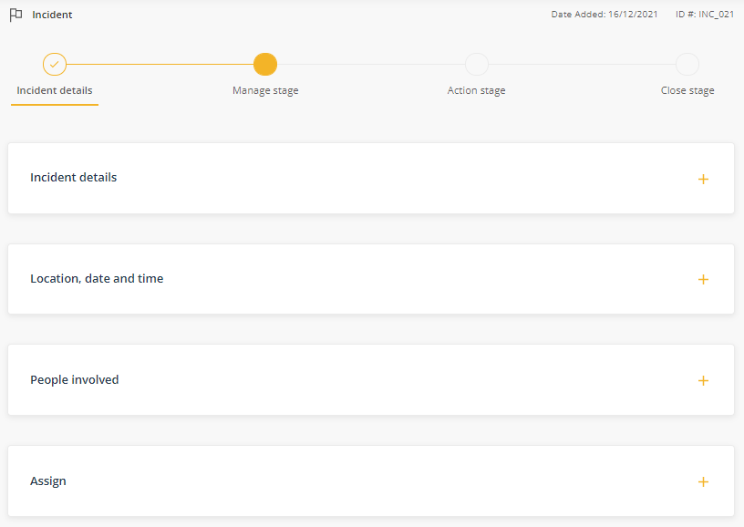
Once you complete the required fields, you can attach any relevant records or photos and submit to the report.
After you report the incident, it will move to the Manage stage where you or someone else can decide what action should be taken to manage the incident.

Incident details component
In this component you will describe broadly what happened, why it may have happened and what immediate steps were taken to respond to the incident. The table below describes each field in the component.
Field name | Description | Required
Incident type | Select the nature of the issue.  An incident any unplanned event resulting in, or having a potential for injury, ill health, damage or other loss.  A near miss is an incident that could have resulted in an injury or illness to people, danger to health, and / or damage to property or the environment.  A hazard is an object or situation that has the potential to harm a person, the environment or cause damage to property. | Yes
Incident area | Select the area the incident relates to i.e. Clinical, Operational or WHS. This will reveal the incident category menu. | Yes
Is this incident related to a pandemic/epidemic? | If this incident is related to a pandemic/epidemic (e.g. COVID-19) please select yes. For example, aggression from a visitor because of restricted visiting, patient to staff spread, unavailable PPE. | Yes
Is this incident related to care provided by this organisation? | Specifies if the incident is related to care provided by your organisation. | Yes
Did the incident involve company assets/equipment/ vehicles? | If company assets, equipment, or vehicles were involved in the incident, additional fields will be revealed | Yes
Brief summary | Provide a brief description of the incident in approximately 25 words or less. | Yes
Description of incident | Provide a detailed description of what happened in approximately 800 words or less. Note you can attach records to your report such as witness statements etc.  This field should include a clear, concise description of the event. It should be factual, objective and be easy to understand. Please do not include identifying information (eg. patient or staff names) as this information is used by the Victorian Agency for Health Information, Safer Care Victoria and the Department of Health and Human Services. For more information refer to your health services incident reporting policy and procedure or https://bettersafercare.vic.gov.au/sites/default/files/2018-03/incidentreportwriting%20-%20PDF.pdf. | Yes
Contributing factors | Describe why the incident may have happened eg the possible causes. | Yes
Assign a severity rating | Define how severe the incident is using your organisation’s severity rating scale. You can select the guide to assist you assess the appropriate rating. | No
Immediate action taken | Describe actions taken after the incident occurred i.e. What did you do? | Yes

Location, date and time component
In this component you define where and when the incident occurred. The table below describes each field in the component.
Field name | Description | Required
Organisation | Identifies the organisation accountable for the incident. This fields will be set to your organisation by default. | Yes
Campus | Identifies the site where the incident occurred. | Yes
Specialty/unit | Identifies the area of the organisation related to the incident. | Yes
Date and time of incident | The date on which the incident occurred and the time it happened. | Yes

People involved component
In this component you define the person or people involved in the event. Click Add to add a person. Note: If there are no known people involved, you don’t have to complete this component, however, it will be required if the incident is to be submitted to VAHI. The table below describes each field in the component.
Field name | Description | Required
Who was involved | Defines the ‘type’ of person involved eg. patient/client, staff member, or visitor. | Yes
Name | First and second name of the person. | Yes
ID# | The unique ID number of the client. | Client only
Gender | The gender with which the person identifies. | Varies
Date of birth | The person’s date of birth if known. Note: this field will be required later if the incident is reported to VAHI. | Optional
Other people/witnesses | Free text field to record further information and/or names of other people involved in addition to those recorded in ‘Who was involved’. | Optional

Recording event types
Event types allow for further details about the incident to be recorded for each person involved. At least one event type is required if the incident will be reported to VAHI. Clicking the preview icon in the People involved component will open a page where further ‘Person event details’ can be recorded. Note: These fields vary depending on the ‘type’ of person involved and are mandatory if the incident is to be reported to VAHI. The following page describes how to complete the Person event details component.

Person event details component (Clinical)
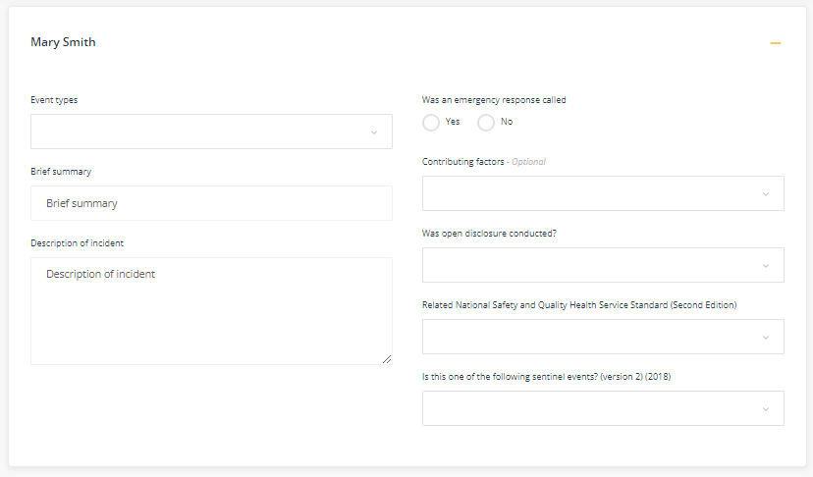
Field name | Description | Required
Event types | This control allows you to classify the event. You can select one or more event types in any order (i.e. the order you select the event types does not indicate which is most relevant or important). The event type you select will determine the additional questions you will be required to answer. | Yes
Brief summary | This field will be populated automatically with the content you entered in the Incident details section. | Yes
Description of incident | This field will be populated automatically with the content you entered in the Incident details section. | Yes
Was an emergency response called | Relates to the immediate action taken. | Yes
Contributing factors | Analysis of the factors that may have contributed to the incident occurring. | Clinical only
Was open disclosure conducted? | Relates to the process undertaken with the client. Open disclosure is an open discussion with a patient / consumer about an incident(s) that resulted in harm to that patient / consumer, while they were receiving health care. Open disclosure discussions also include the patient's family, carer and/or support person. | Clinical only
Related National Safety and Quality Health Service Standard (Second Edition) | Menu to link the incident to one of the standards in the NSQHS standard. | Clinical only
Is this one of the following sentinel events? (version 2) (2018) | Menu to classify the incident as a sentinel event. | Clinical only

Incident Severity Rating
Clinical
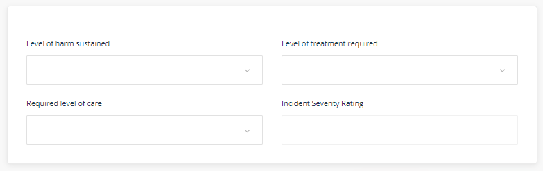
OHS
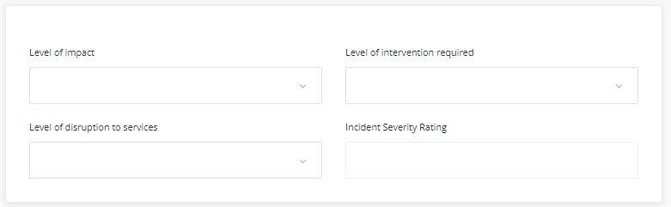

Field name |  | Required
Level of harm sustained | These fields determine the clinical incident severity rating  (ISR). ISR is used to group incidents with similar levels of  harm and to assess the degree of investigation needed. | Clinical
Required level of care |  | Clinical
Level of treatment required |  | Clinical
Level of impact | These fields determine the hazard incident severity rating.  ISR is used to group hazards with similar levels of impact  and to assess the degree of investigation needed. | OHS
Level of disruption to services |  | OHS
Level of intervention required |  | OHS
Incident Severity Rating | Automatically calculated based on selections above.

A full guide to assist in selecting the correct level of severity is provided in Appendix 1.

Assign component
If your organisation has implemented the Business Rules Builder feature, some or all of the assign fields will be pre-populated and not editable. This feature helps to ensure the Incident is assigned correctly and makes it easier for the user to report.
Field name | Description | Required
Related business area | Select the business area that relates to the reported incident. | Yes
Related meeting | Select the team who is likely to be responsible for monitoring the issue and ensuring the incident is managed. It might be the team closest to the related business area. | Yes
Report this issue to | Select the person to manage the incident. The person you select will be immediately notified of your report and will receive a task to manage the issue.  Note: If you have the permissions to tick 'Assign to me' you will be selected to manage the issue and the form submit button will change to 'Next' allowing you to advance directly to the Manage stage. | Yes
Viewing permissions | Select the viewing permissions to set who will be able to view the incident. If you're not sure who is in each group, hover your mouse over 'Who can view'. | Yes
Add additional users for viewing permissions | If other people need to see the incident outside of the people in the selected role group, select their names in this field. | Yes
User notification | The people or groups you select here will receive an email notifying them about the incident. It's just a notification, not a task. Their email will contain a link to the incident but they will still need to have the required viewing permissions to see the full details. | Yes

Managing Incidents

Overview
Once an incident is reported, it will move to the Manage stage in the workflow. In the Manage stage you decide how to respond to the reported incident. This stage is your opportunity to ensure the response complies with internal policy and procedures, and any protocols specified by external agencies.

How to manage an incident
- Select an option in the Task management component.
- Complete the required fields.
- Click the green ‘Submit’ button (It will say ‘Next’ if you assign the incident to yourself to manage)
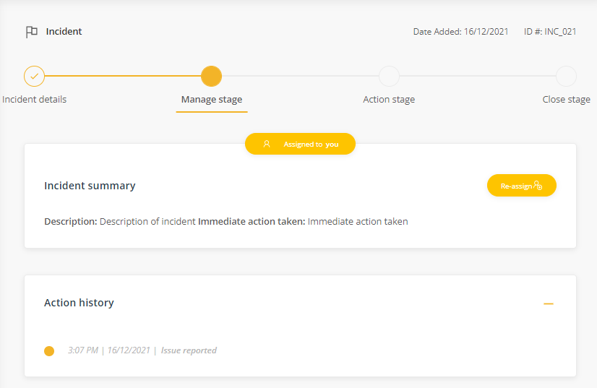
The Incident summary component contains the full description of the incident and the immediate actions that were taken when the incident occurred.
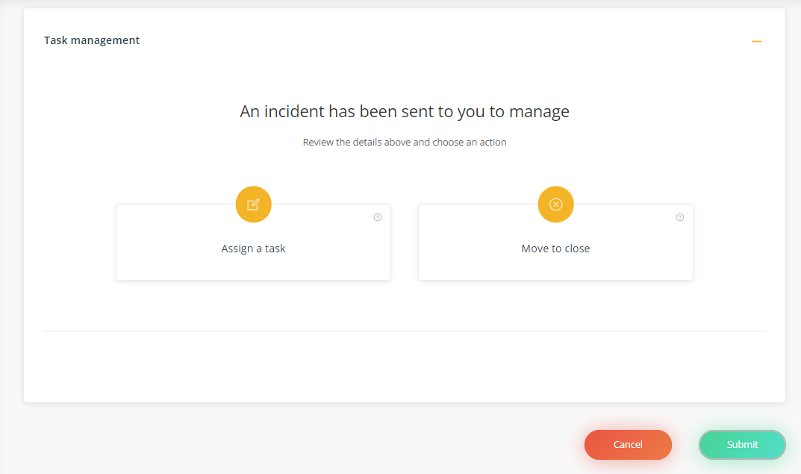

To Manage the incident one of the Task options (Assign a task or Move to close) must be selected.
Field name | Link to help articles for these options | Required
Assign a task option | Use this option to set an action for yourself or someone else in relation to the incident. Full details on this option are found here: https://knowledgebase.logiqc.com.au/managing-incidents | Yes, one option must be selected
Move to close option | Use this option to record the outcome of the what’s been done and finalise the incident. Full details on this option are found here: https://knowledgebase.logiqc.com.au/managing-incidents

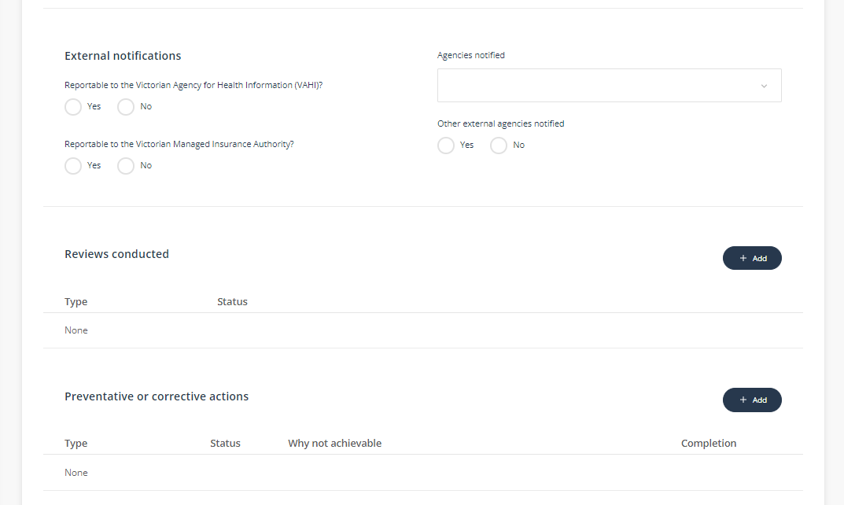

Field name | Description | Required
Reportable to the Victorian Agency for Health Information (VAHI)? | Select Yes if the incident should be automatically reported to VAHI when it’s closed in the LogiqcQMS. The incident will not transfer to VAHI until it’s closed out in LogiqcQMS by the authorised person. | Yes
Reportable to the Victorian Managed Insurance Authority? | Select yes if the incident should be reported to the Victorian Managed Insurance Authority. This is a data attribute only. The information will not be automatically transferred to the VMIA. | Yes
Agencies notified | Select the agencies notified about this incident. If the incident does not require reporting to external agencies, select ‘Not required’. | Yes
Reviews conducted | This component allows for a summary of the types of reviews conducted in relation to the incident. | Optional
Preventative or corrective actions | This component allows for a summary of the types of actions taken in relation to the incident. | Optional

Closing Incidents

Overview
Once an incident is managed, it will move to the Close stage in the workflow. In this stage. In the Close stage you can assign further actions or close out the incident. If the incident in reportable to VAHI, the electronic submission will occur when you complete and save this form. Confirmation of this submission is recorded in the item’s System Event History:
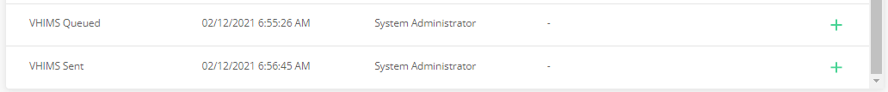

How to close an incident
- Select an option in the Task management component.
- Complete the required fields.
- Click the green ‘Close’ button
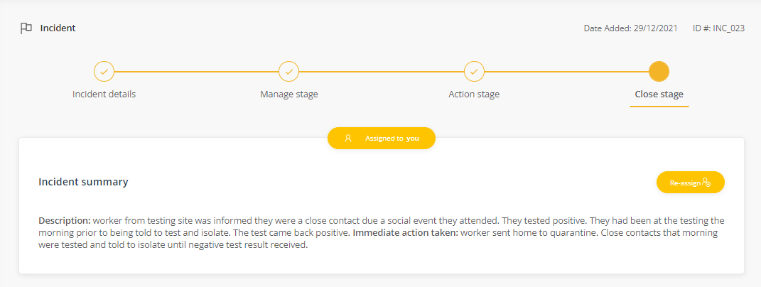
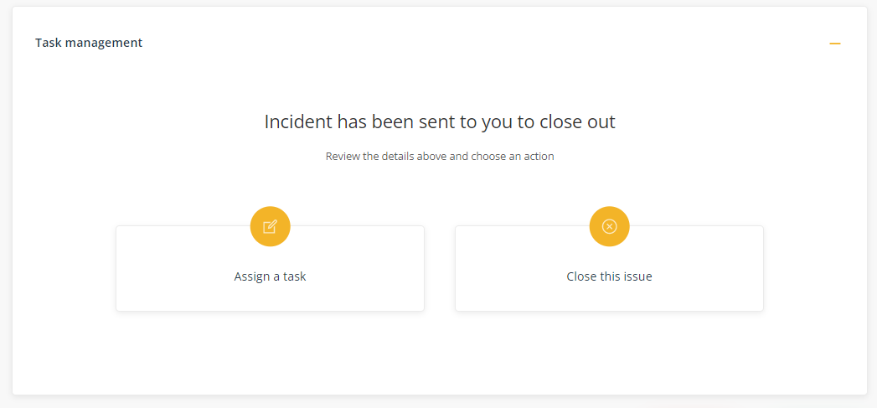

To close the incident one of the Task options (Assign a task or Close the issue) must be selected.
Field name | Link to help articles for these options | Required
Assign a task option | Use this option to set an action for yourself or someone else in relation to the incident. Full details on this option are found here: https://knowledgebase.logiqc.com.au/managing-incidents | Yes, one option must be selected
Close this issue | Use this option to record the finalise and close the incident. Full details on this option are found here: https://knowledgebase.logiqc.com.au/managing-incidents

The components for below that first appeared in the Manage stage are also presented in the Close stage along with any entries already made. You can edit the entries already made and add additional items.

Field name | Description | Required
Reportable to the Victorian Agency for Health Information (VAHI)? | Select Yes if the incident should be automatically reported to VAHI when it’s closed in the LogiqcQMS. The incident will not transfer to VAHI until it’s closed out in LogiqcQMS by the authorised person. | Yes
Reportable to the Victorian Managed Insurance Authority? | Select yes if the incident should be reported to the Victorian Managed Insurance Authority. This is a data attribute only. The information will not be automatically transferred to the VMIA. | Yes
Agencies notified | Select the agencies notified about this incident. If the incident does not require reporting to external agencies, select ‘Not required’. | Yes
Reviews conducted | This component allows for a summary of the types of reviews conducted in relation to the incident. | Optional
Preventative or corrective actions | This component allows for a summary of the types of actions taken in relation to the incident. | Optional

Appendix 1: Incident Severity Ratings guide
Field name | Description | Required
Level of harm sustained | No harm: There was no harm to the subject either as the incident did not reach the subject or it did, but no harm did not impact their usual level of health and function.  Harm: One or more systems or components of the subject's body are no longer able to operate as they did prior to the incident (impacting their usual level of health and function).  Death: The subject died at the time or following the incident. | OHS
 | No harm - Did not reach person: There was no harm to the subject, that is, the incident did not reach the subject. For example: the incorrect dose or type of medication was prescribed/dispensed but not administered to patient.  No harm - Did reach person: The incident reached the subject, but there was no harm caused. For example: Delayed treatment/theatre, absconding, missed medication, vasovagal which does not result in harm or negative consequences for the subject.  Harm - Temporary (Minor): One system or component of the subject's body are temporarily unable to operate as they did prior to the incident. The subject is likely to recover from this in the short to medium term. For example: An incident which results in temporary loss or reduction in functioning including hospital acquired infection, laceration, fracture, weight loss, self-harm, pressure injury/skin tear, burn, psychological harm.  Harm - Temporary (Moderate): Two or more systems or components of the subject's body are temporarily unable to operate as they did prior to the incident. The subject is likely to recover from this in the short to medium term. For example: An incident which results in temporary loss or reduction in functioning including (two or more of the following) hospital acquired infection, laceration, fracture, malnutrition, significant weight loss, self-harm, pressure injury/skin tear, burn, psychological harm.  Harm - Permanent: One or more systems or components of the subject's body are no longer able to operate as they did prior to the incident. The subject is not likely to recover from this loss or reduced functioning. For example: in permanent loss or reduction in functioning including complications of surgery/ procedure/ inpatient admission, hospital acquired infection, medication error, self-harm, pressure injury/skin tear, burn, psychological harm.  Death: The subject died unexpectedly at the time or following the incident due to system/process deficiencies and not their underlying condition. For example: misdiagnosis, delay in recognising / responding to deterioration, complications of resuscitation linked to procedural or equipment failures, complications of an inpatient fall, complications of a procedure/surgery. | Clinical
Required level of care | Current setting - No change: The subject did not require additional care or to be moved from their current location as a result of the incident.  Current setting - Increased observations or monitoring: The subject required increased observation or monitoring within their current setting.  Internal/external transfer for diagnostic test or monitoring only: The subject was transferred for required diagnostic testing or increased monitoring not available in current location. For example: transfer to a facility with x-ray and CT as diagnostic imaging is not on site.  Internal transfer for advanced/specialised care: The subject was transferred to another campus within the same health care service for a higher level of care or specialty not available in current location. For example: the patient is in an aged care facility and is transferred to the acute campus of the same health care network for an orthopaedic review of a suspected fracture.  External transfer for advanced/specialised care: The subject was transferred externally to another health care service, for a higher level of care or specialty not available in current location. For example: a patient in a regional hospital is transferred to a metropolitan tertiary service following referral to their neurosurgical high dependency unit for surgical treatment of a subarachnoid haemorrhage. | Clinical
Level of treatment required | No treatment: Following review, intervention was deemed not required. Review includes: GP, emergency department, MET, VMO. For example: Injury reviewed by medical staff but no treatment was required.  Minor treatment: The subject required a simple or minor intervention or first aid as a result of the incident. For example: blood tests, simple dressings, analgesia.  Intermediate treatment: The subject required a referral, a simple procedure or more advanced diagnostics. For example: CT/MRI, suturing, insertion of nasogastric tube, urinary catheter insertion, evacuation of haematoma, >5 physiotherapy sessions, MET/Code Blue resulting in O2 therapy, administration of anti-arrhythmic or reversal of medications.  Advanced treatment: The subject required significant in hospital medical, diagnostic or surgical intervention as a result of the incident. For example: Surgical intervention to treat life threatening haemorrhage or organ perforation, surgical/medical referral to treat injury, MET/Code blue resulting in advanced life support (e.g. rescue breathing, cardiac compressions, ventilation, treatment of anaphylaxis) insertion CVC or PICC line, emergency defib, pacemaker insertion, administration of noradrenaline/dopamine, haemofiltration/dialysis, insertion of an Intra-aortic balloon pump.
Level of impact | No impact - Could have happened: A condition within the workplace which has the potential to cause harm. For example: Potential for manual handling injury due to staff moving heavy boxes, frayed lead to bed, wheelchair wheels jamming.  No impact - Did happen: A condition within the workplace which had the potential to cause harm but didn't. For example: Exposure to pest infestation in staff tearoom, frayed carpet results staff tripping without injury, poor ventilation, poor lighting, glare.  Minor impact - Local area: A condition within the workplace which had a minor impact on the local area. For example: exposure of staff to pharmaceutical waste especially cytotoxic agents.  Moderate impact - Local campus: A condition within the workplace which had a moderate impact on the campus. For example: presence of asbestos throughout campus, radioactive waste from nuclear medicine, presence of ligature points in mental health unit.  Major impact - More than one campus/organisation wide: A condition within the workplace which had a major impact across the organisation. For example: Biological waste from clinical areas is not disposed of safely. | Yes
Level of disruption to services | No or minimal disruption < 1 hr: For example: inappropriate storage of medication, emergency exit light not illuminated, air conditioning not working properly.  Minor disruption < 24 hrs: For example: lifts not opening on level requiring lift company to decommission lift until it can be fixed.  Moderate disruption > 24 hrs: For example: poorly maintained equipment which takes more than a day to repair.  Major shutdown of unit or site: For example: site is shut down as due to flooding. | Yes
Level of intervention required | Describes the scale of the response required. | Yes
Incident Severity Rating | The incident severity rating (ISR) is calculated based on the answers to the questions above. It is based on a World Health Organisation algorithm, adapted and refined by subject matter experts from Victoria health services. This value cannot be edited but will change if the answers to the above fields are updated. The ISR is used to determine who within your health service should be notified of this event. | Yes

