LogiqcQMS v7 Quick Start Guide

LogiqcQMS Build Workbook

Table of Contents
Logging in 3
Homepage 3
Updating your password and account details 4
Reporting an event (Incident, Improvement, Feedback, Repair) 4
Adding a register item 4
Viewing documents 5
Completing a Task 5
Accessing the Learning Academy 6

Logging in
- Open your Internet browser (e.g. Google Chrome, Microsoft Edge) and enter your LogiqcQMS web address (URL)
- Enter your username and password, and click log in. If you’ve forgotten your password, click the ‘Forgot password’ link
Related Knowledge base articles:
How to log in

Homepage
When you log into LogiqcQMS, you will open at the homepage.

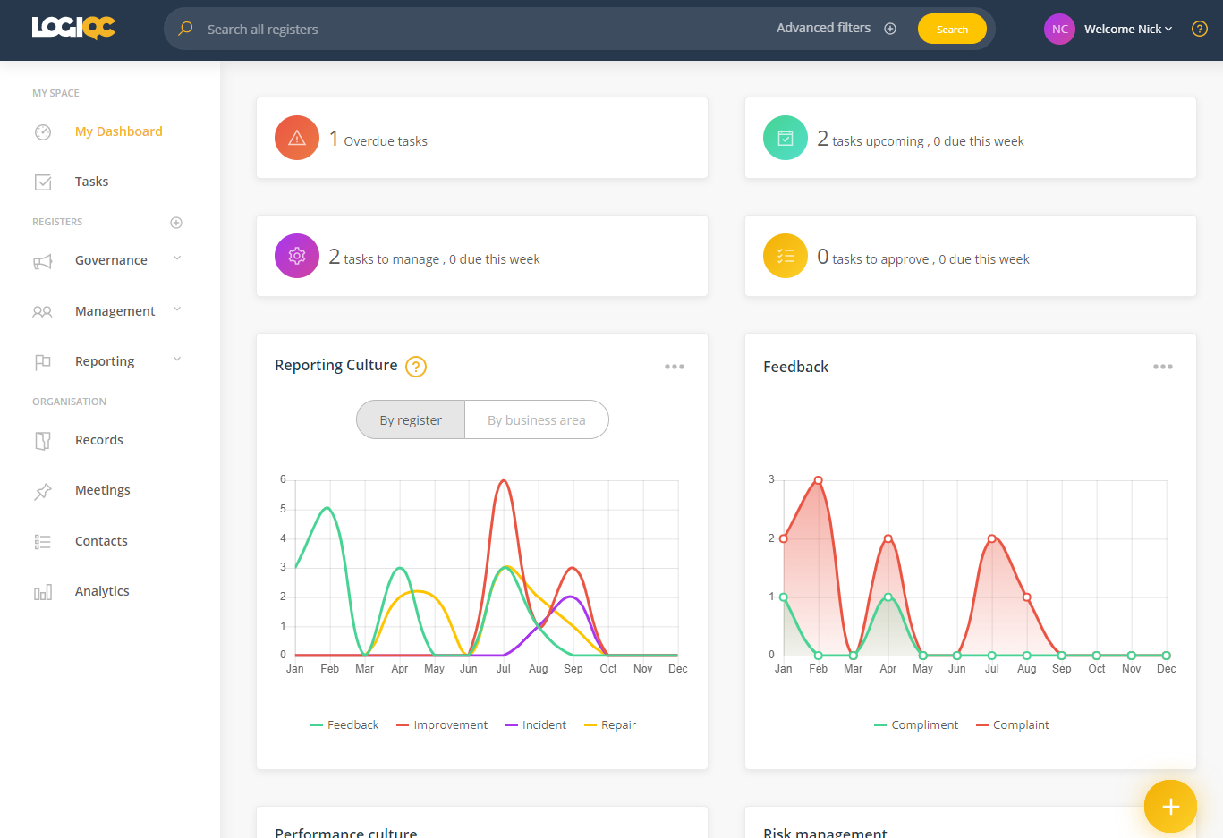
Add new items here with the FAB (Floating Action Button)

Navigate the system using this left nav panel

Link to the Help Centre

Access your account details

Search all registers here

Updating your password and account details
- After logging in, click on your name (top right), and select ‘My Account’
- Click ‘Change password’ to enter a new password and click ‘Ok’.
- Make sure your email address is correct. This is the address Logiqc will send task notifications and meeting reminders to.
- Update you phone numbers (optional)
- Click ‘Save’ to update your account.
Related Knowledge base articles:
Changing your password
Editing your user account

Reporting an event (Incident, Improvement, Feedback, Repair)
- Click on the FAB (see page 1) and select the event type you need to add.
- Describe the details of the event.
- Assign the item to the appropriate person and the relevant Meeting and Business area.
Related Knowledge base articles:
Report an incident
Report a complaint
Report feedback
Report a repair

Adding a register item
- Go to the relevant register and click on the FAB.
- Define the details of the item.
- Assign the item to the appropriate person and the relevant Meeting and Business area.

Viewing documents
- Use the left nav panel (see page 1) to go to the Document Register.
- Search or filter for the document.
- When you have found the required document, click on the icon in the View column to open a preview.
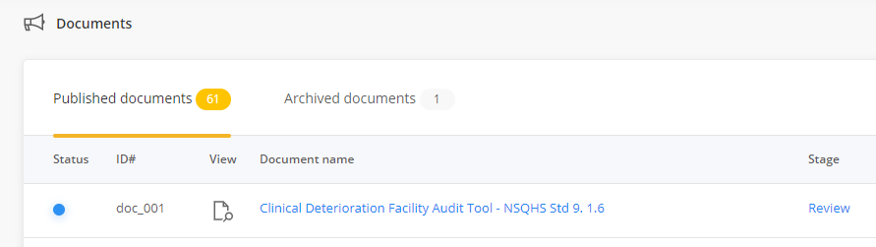

Completing a Task
- If you have been assigned a task you will receive an email notification and the task will be listed in your Tasks Register in the My tasks tab. Click on the Description of the task to go to your task management options.
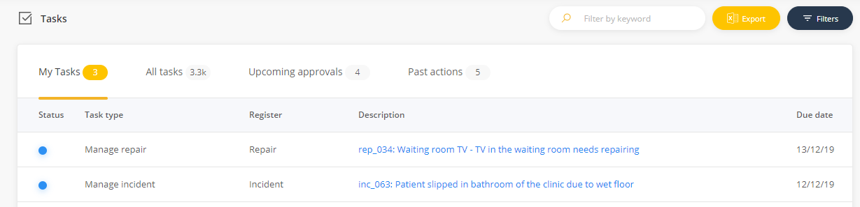

Related Knowledge base articles:
About tasks

Accessing the Learning Academy
The LogiqcQMS Academy has a variety of self-paced courses designed to help you get the most from your LogiqcQMS.
Knowing how to use the platform is one thing but understanding why is the next piece in the puzzle.
Our courses are designed to provide context and rationale for implementing a QMS and will explore how to position quality as a strategic driver in your organisation.
Follow this link https://academy.logiqc.com.au/ to access the Academy.
Courses recommended for new staff
Introduction to LogiqcQMS
Report an Incident
Report feedback
Suggest an improvement or report a non-conformance
Related Knowledge base articles:
Accessing the LogiqcQMS Academy

PO Box 483, Paddington, Qld, Australia 4064
AU +617 3216 0335 NZ 0800 002 280 E: info@logiqc.com.au W: logiqc.com.au

